Assignment-26.3:

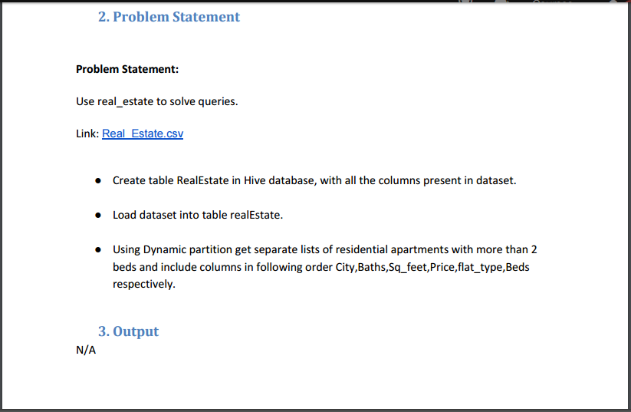

Creating a table named real estate with all the columns and the data is loaded into the table.

The contents of the table is displayed.

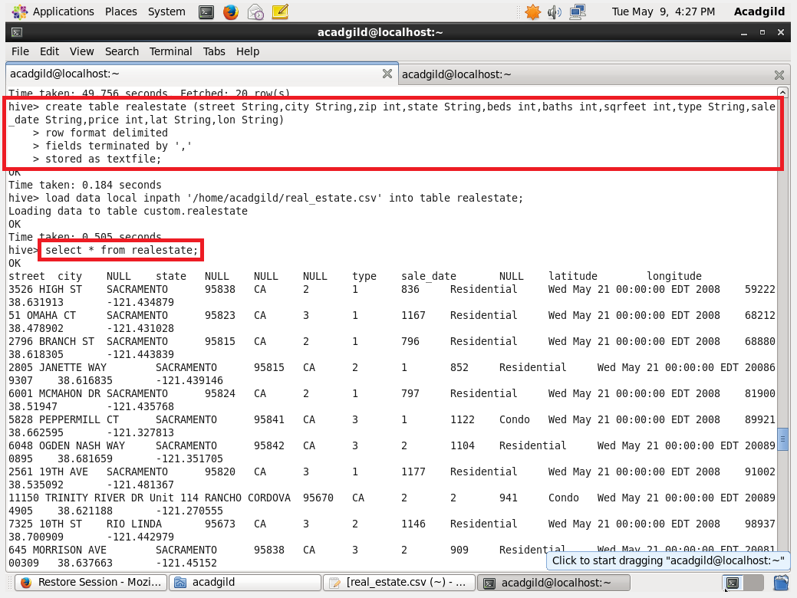

Creating a partition table partitioned by type, beds.

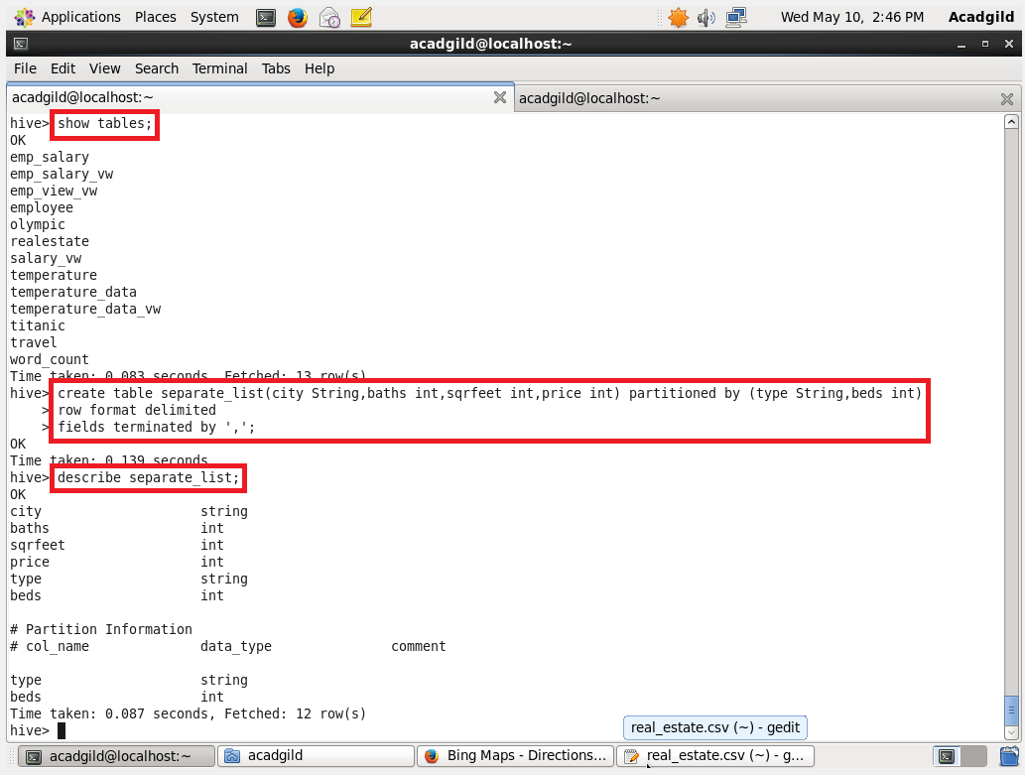

Setting the dynamic partition and inserting the partitioned data into the partitioned table.

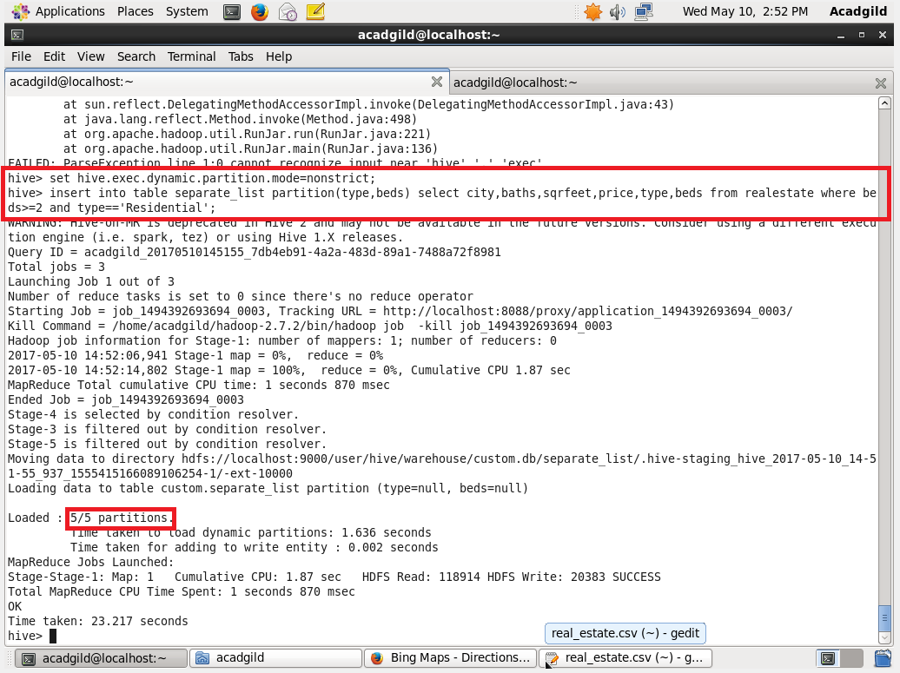

The different partitions are displayed which is stored in the hdfs. Here we can see that the partitioned has been done dynamically.

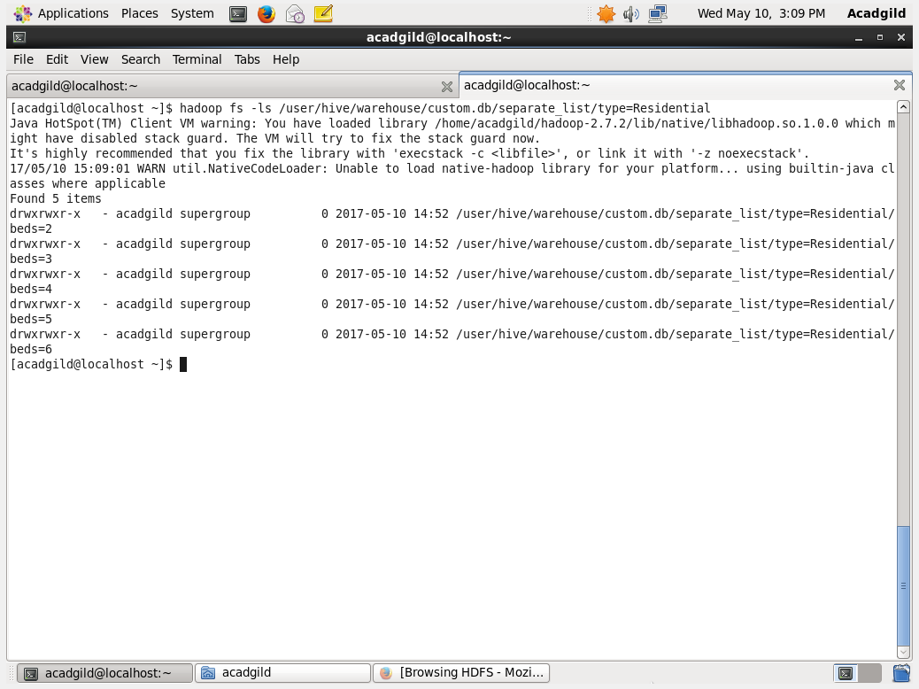

The contents of the file is displayed

